

Hawassa University

Faculty of Informatics

**Departments of Computer Science & Information Systems**

**Hosting Company:** HU – Faculty of Informatics | CACSI

**Duration of Stay**: September 18 – November 10, 2023

**Apprenticeship Report**

**By:**

1. Destaw Aschaew (IS) NaScR/0845/13
2. Zebib Fekadu (CS) NaScR/2787/13
3. Kidist Tesfaye (CS) NaScR/1512/13
4. Rahel Fekede (IS) NaScR/2047/13

**Advisor:** Mr. Solomon

**Submission date:** November 20, 2023

**Hawassa, Ethiopia**

**Preliminary**

**Declaration**

I hereby declare that this Apprenticeship Report has been supervised by Mr. Solomon, Lecturer of the Department of Computer Science at Hawassa University. I further assure that this Internship report has not been submitted either in whole or part for any Degree or Diploma in any university previously. I further undertake to indemnify the university against any loss or damage arising from breach of the foregoing obligation.

----------------------

Signature and Date

**Acknowledgement**

We are extremely grateful and remain indebted to God who has guided in all ventures to successfully complete our Internship report. We are thankful to the grace and the help received from him.

This Apprenticeship report would not be success, without the constant and valuable guidance of Mr. Solomon, our supervisor for the Internship, who is rendering all sorts of help as and when required. We are thankful for his constant constructive criticism and valuable suggestions, which benefited us a lot while implementing the Internship. He has been a constant source of inspiration and motivation for hard work. He has been very cooperative throughout this Internship work.

Through this column, it would be our utmost pleasure to express our warm thanks to Dr. Tesfaye, our hosting Company’s advisor for his encouragement, cooperative and consent. We would also like to appreciate his valuable guidance throughout the whole duration of the apprenticeship program

We are also thankful to Mr. Wogene, head of the Department of Computer Science for giving us this chance to gain a valuable experience of the real world. We will always be indebted for the love and care that our parents have showed on us, and have done every possible effort to reach us at this stage.

**Executive Summary**

This internship report is based on the internship program that we had successfully completed at Hawassa University Informatics Faculty from 18//2023 to 10//2023 as a requirement of our BSc. Program on Department of Computer Science & Department of Information Systems.

During our internship at HU- Informatics Faculty we were assigned to work on the CACSI unit which is responsible for advanced computing & software innovation. We were assigned to develop a web portal that tracks & showcases projects that have been undertaken by our faculty including the future projects.

The report covers a detailed analysis of the tasks and projects undertaken, the skills and knowledge acquired, and the overall impact of the internship on my professional development. It also includes reflections on the challenges faced and the strategies employed to overcome them, as well as recommendations for future interns and areas of improvement for the organization.

It is organized in 7 parts that describe the whole program. In the first part, we tried to explain about the brief history & background of The Hawassa University & Nurture Project that we were assigned to. We also included the overall organizational structure & work flow of the university.

The second part is all about how we got into the company & which section that we’ve been working on. It also contains the tasks that were given to us as a beginner. The third part covers the general & specific objectives of this program.

The workflow of the section, the tasks we executed & procedures we took & that challenges we faced are included in the fourth part while the knowledge we gained in terms of practical skills, theoretical knowledge, communication skills, team & leadership skills are covered in the fifth part.

The seventh part discusses about our internship project. The project objective, plans & methodology are briefly discussed in this part. We finalize this report by discussing some recommendation for the university & the section we’ve been working on.

**List of Tables & Figures**

* Fig 1.1 HU Organizational Structure ------------------------- 10
* Fig 6.1 Home Page --------------------------------------------- 22
* Fig 6.2 Home Page (2) ----------------------------------------- 22
* Fig 6.3 Projects Page ------------------------------------------- 23
* Fig 6.4 Projects Page (2) --------------------------------------- 23
* Fig 6.5 About Us Page ----------------------------------------- 24
* Fig 6.6 About Us Page (2) ------------------------------------- 24
* Fig 6.7 Admin Dashboard ------------------------------------ 25
* Fig 6.8 Admin Dashboard (2) --------------------------------- 25
* Fig 6.9 Users Page --------------------------------------------- 26
* Fig 6.9 Projects Page | Admin ------------------------------- 26
* Fig 6.10 ER Diagram ------------------------------------------ 30
* Fig 6.11 2nd Normal Form ----------------------------------- 31

**Index**

1. Introduction
   1. History of HU – Informatics Faculty --------------------------------- 8
   2. History of Nurture Project --------------------------------------------- 9
   3. Main products, services & customers -------------------------------- 9
   4. Organization & workflow --------------------------------------------- 10
2. Statement of the problem --------------------------------------------------- 11
3. Objectives of study
   1. General Objective ------------------------------------------------------ 12
   2. Specific Objectives ----------------------------------------------------- 12
4. Materials & Methodology -------------------------------------------------- 13
5. Results & Discussion ------------------------------------------------------- 15
6. Apprenticeship Project
   1. Introduction to the project --------------------------------------------- 21
   2. Statement of the problem ---------------------------------------------- 21
   3. Methodology ------------------------------------------------------------ 22
   4. Functional & Non-functional Requirements ------------------------ 22
   5. Wireframe & Prototype ------------------------------------------------ 23
   6. Database Design -------------------------------------------------------- 28
7. Conclusion & Recommendation
   1. Conclusion -------------------------------------------------------------- 33
   2. Recommendation ------------------------------------------------------ 34
8. References ------------------------------------------------------------------ 35
9. **Introduction**
   1. **History of HU – Informatics Faculty**

Hawassa University (HU) is one of the first-generation universities in Ethiopia whose establishment was laid as Awassa College of Agriculture (ACA) in 1976 with the admission of 217 students. It was later restructured and promoted to a university in 2000, named “Debub University” with the merger of ACA and two other colleges in southern Ethiopia: Wondogenet College of Forestry and Natural Resources, established in 1978; and Dilla College of Teachers’ Education and Health Sciences, established in 1996. In 2006, it was renamed “Hawassa University” with the addition of its main campus in Hawassa, and Dilla College of Teacher’s Education and Health Sciences evolved to a separate university on its own.

The informatics faculty was established as Department of Computer Science and Information Technology in 2003, with a Diploma (12+2) study program. The faculty named as Department of Computer Science in 2004 and started Bachelor's Degree in Computer Science. In 2007, IT and IS study programs are commenced. The university launched the Postgraduate study program in CS started in 2016.

CACSI is envisioned to house students and instructors research and project activities. Thus, the center is hosting and will host project related meetings, seminars and allows students to sit and undertake scientific and technology transfer project activities.

**Vision:**

Hawassa University aspires to be one of the top ten East African research universities by 2030.

**Mission:**

Hawassa University strives to produce efficient and internationally competent graduates and undertake innovative works, rigorous research and technology transfer activities to foster social and economic development of the country.

HU has been largely contributing its part to the overall development of the country through teaching, training, research and community services over the last 46 years by establishing and improving different centers of excellence at colleges, institutes and university levels.

* 1. **History of Nurture Project**

NURTURE is a joint project between the Norwegian universities of University of South-Eastern Norway (USN) and the University of Oslo (UiO) and the Ethiopian universities of Addis Ababa Science and Technology University (AASTU), University of Gondar (UoG), Debre Markos University (DMU), Hawassa University (HU), and Jimma University (JU). This joint project is funded by the Norwegian Funding company NORAD.

NORHED is the Norwegian Program for Capacity Development in Higher Education and Research for Development. NORHED aims to strengthen the capacity of higher education institutions in developing countries to produce higher-quality graduates, more and higher-quality research, and more inclusive higher education.

Higher education and research are priority areas of Norway’s development cooperation policy. Sound, strategic investments in higher education and research lay the foundation for development of countries’ intellectual resources, competent workforces, visionary leaders, gender equality, human rights and democracy. NORAD supports university partnerships for North-South-South academic collaboration, as outlined in the NORHED Program Document.

* 1. **Main Products, Services & Customers**

The university offers a wide range of products and services including education, training, research, community service, and technology transfer activities. These offerings are designed to cater to the needs of both students and external communities. The education and training programs aim to provide comprehensive learning experiences for students, while the research and technology transfer activities are geared towards fostering innovation and knowledge exchange. Additionally, the community service initiatives are focused on giving back to the external communities by providing support and resources. These services are tailored to meet the diverse needs of our students and external communities, ensuring that they receive valuable and impactful experiences.

NURTURE's primary offerings include capacity development in eHealth, informatics, and special needs education. The project introduces three new master programs, revises 16 curricula, and supports scholarships for 45 MSc and 15 PhD candidates. Digital solutions for sensory-impaired students, boot camp seminars, and enhanced access to digital content through eLearning platforms and infrastructure development are integral components of the project.

The main beneficiaries of NURTURE are the students and faculty of the participating universities in Ethiopia and Norway. By prioritizing quality education, job creation, and inclusivity, the project aims to impact not only the immediate academic community but also contribute to broader societal development. Special emphasis is given to gender equality, with 50% of scholarships allocated to female staff and support for economically disadvantaged female students.

* 1. **Organization & workflow**

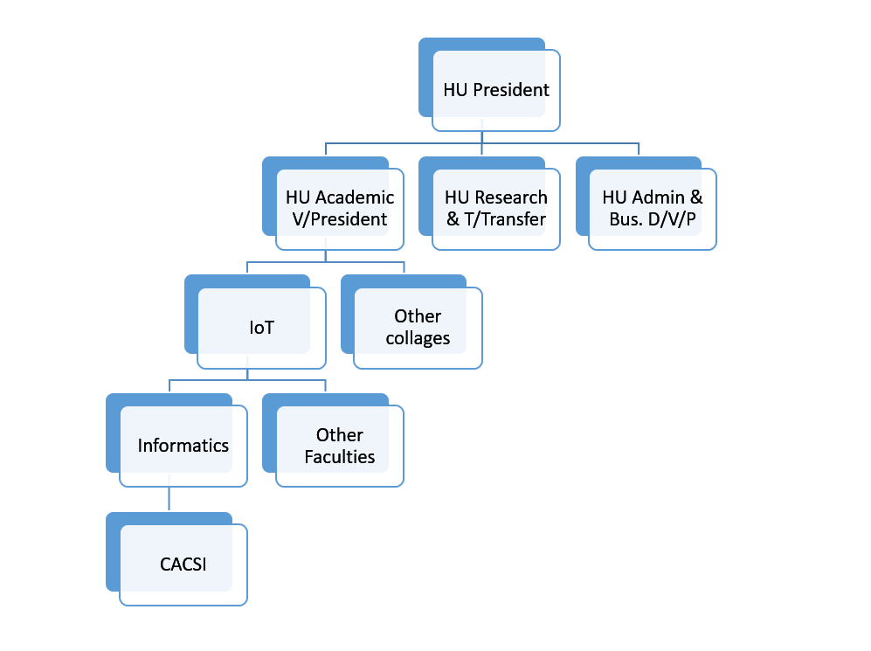

Fig 1.1 HU Organizational Structure

CACSI is a new setup under Informatics. It is emerging Centre and has no complex internal organization structure. It is a place where students and instructors work in "high-impact" project that is relevant for the community and/or can attract external fund.

NURTURE's organizational structure involves collaboration between Norwegian and Ethiopian institutions. The project focuses on staff capacity development, interdisciplinary research, curricula revitalization, and digitalization. The workflow includes the implementation of new master programs, curricula revisions, scholarship support, and the development of digital solutions to address specific educational challenges.

1. **Statement of the problem**

The internship program is one way of implementing industry – university linkage. Most academic programs have a minimum of one semester industrial apprenticeship program as part of their undergraduate degree program. Our Faculty, informatics is designed to have an internship program at the second semester of third year. Even though the duration of the program was shortened due to the inconvenience cause by the schedule being messed up, we attended the program on the scheduled time. Since we had a connection with CACSI before this apprenticeship program, the section accepted us happily when we applied. We were given chance to experience what a real work environment looked like.

We worked as web developers for the section. Our main task was to develop a web portal showing past experiences/project and future strategies. The website we are planning to develop aims to showcase these projects and provide information about the activities that took place during the incubation period, the students who participated, and the services they received.

1. **Objectives of study**
   1. **General Objective**

The general objective of this internship program is to provide us with practical learning opportunities and real-world experience in our field of study. It aims to help us apply theoretical knowledge to practical situations, develop professional skills, and gain insights into the tech industry. This apprenticeship also aims to foster a collaborative and supportive environment for us to learn from experienced professionals, build our network, and gain valuable feedback and mentorship. Ultimately, this program seeks to prepare us for our future careers and help us make informed decisions about our professional goals.

* 1. **Specific Objectives**

Below are the specific objectives of this apprenticeship program.

**Over all Skills:**

* To gain practical experience in a professional setting
* To apply theoretical knowledge to real-world situations
* To develop new skills and competencies
* To network with professionals in your field
* To make a positive contribution to the organization
* To determine if a particular career path is a good fit for you

**Technical skills:**

* To learn how to use specific software or equipment
* To develop proficiency in a particular programming language
* To gain experience in conducting research and analysis

**Soft skills:**

* To improve communication and interpersonal skills
* To develop teamwork and collaboration skills
* To enhance problem-solving and critical thinking skills

**Industry knowledge:**

* To gain a deeper understanding of a particular industry or sector
* To learn about the latest trends and developments in the field
* To become familiar with the professional culture and expectation

1. **Materials & Methodology**

Since CACSI is a new setup under Informatics, it is just an emerging Centre and has no complex internal organization structure.

The flow in the section looked something like this:

* Any Faculty staff/student with high-impact project idea submit a concept note to Faculty of Informatics.
* A committee sees & evaluates the idea
* If it is found relevant, the person (or a team) get a place to work together in CACSI facilities.

There is also a female corner to encourage female technologists. They have an open setup that allows both employees & their bosses to interact openly. Any student of our university & technology institute is eligible to come forward with innovative idea that can be developed into business or even research.

As an employee in the section, we were required to attend each day of our apprenticeship program. We were also expected to arrive at work & leave from work on time. This helped us to practice work place punctuality.

Our main task in the workplace was to develop a website for showcasing the projects, researches, tech transfer & other activities hosted by our faculty ie. Informatics. This website was designed according to the interest of our supervisor in collaboration with our mentor. This website had 5 deliverables. These are:

* Requirement electrician document (high-level)
* Website front end design (architecture)
* Website backend design document (high-level)
* User access and security design
* Deployment-ready website

Our newness to the field being the reason, we had a lot of shortcomings when we were working in the workplace. Being unable to manage our time properly, into draining our energy by following unhealthy cycles of working were some of the challenges we faced during the program. Also the lack of the required theoretical & practical knowledge aided to he lagging of the project.

We had to learn all the skilled that we didn’t have from scratch, & keep up with the project schedule. This also increased our stress & pressure resistance. We trained ourselves in time & energy management. We learned how to balance different aspects of life while we were trying to balance our academic courses & the apprenticeship program.

We also learnt about the software development methodology, agile software development. Through this development we were continuously exposed to time lined meeting & assessment with our mentor, continuous supervision of our supervisor & continuously changing client requirements.

We met with our mentor once a week, every Friday. We would assess the whole week’s progress, evaluate our work, decide on what’s good & what needs to be improved, plan for the coming week & finish our meeting. We would also meet with our supervisor ie. Our client to show what we’ve built, ask for comments & changes of interests & align our work according to the new information we got.

We would continuously watch videos on YouTube about what we didn’t know & consult our mentor if things got out of hand. As a beginner in the field we believe that we have performed well. We tried to overcome our weak sides & strengthened our good sides throughout this apprenticeship program.

We also created a noble relationship with the employees of CACSI that would last longer, even if the apprenticeship program has ended. This student – Mentor relationship has helped us excel in the most important part of skill, which is the practical side of our knowledge.

1. **Results & Discussion**

In the internship program we deal with different things in CACSI. In our Six weeks of internship, we have gained valuable benefits staring from creating awareness about the external work environment to achieve entrepreneurship skills. We have improved our communication skills, practical team playing leadership skills, work ethics entrepreneurship skills an also we have strengthened our theoretical knowledge that we have learnt in previous classes the following are the main benefits we gained from the work environment.

**Improving practical skills:**

Since our academic curriculum is mostly theory focused, we didn’t have that much of practical knowledge to begin with. This program has given us some kind of insight into what kind of practical skills are needed in our field & helped us master some of them. To mention some of the practical skills we have acquired

**HTML:**

* Understanding of HTML syntax and structure: This includes knowledge of HTML tags, elements, attributes, and how they are used to create web pages.
* Ability to create and format text: This involves using HTML tags to create headings, paragraphs, lists, and other text formatting elements.
* Knowledge of linking and embedding media: This includes understanding how to create hyperlinks, embed images and videos, and include other media elements in web pages.
* Understanding of forms and input elements: This involves knowledge of how to create forms, input fields, buttons, and other form elements for collecting user input.
* Ability to use HTML5 semantic elements: This includes knowledge of newer HTML5 semantic elements such as <header>, <footer>, <article>, and <section> to create more structured and accessible web pages.
* Understanding of basic CSS: While not strictly part of HTML, having a basic understanding of CSS (Cascading Style Sheets) can enhance the visual presentation of HTML elements on a web page.

**CSS:**

* Understanding of CSS syntax and structure: This includes knowledge of CSS selectors, properties, and values, and how they are used to style HTML elements.
* Ability to apply styles to text and fonts: This involves using CSS to change the font, size, color, and other text properties of HTML elements.
* Knowledge of layout and positioning: This includes understanding how to use CSS to create different layout and positioning techniques, such as floats, flexbox, and grid.
* Understanding of responsive design: This involves knowledge of how to use CSS media queries and other techniques to create designs that adapt to different screen sizes and devices.
* Ability to work with colors and backgrounds: This includes using CSS to apply colors, gradients, images, and other background styles to HTML elements.
* Understanding of basic CSS3 features: This includes knowledge of newer CSS3 features such as transitions, animations, and transformations to enhance the visual presentation of web pages.

**Javascript:**

* Understanding of JavaScript syntax and structure: This includes knowledge of variables, data types, operators, control structures, functions, and objects in JavaScript.
* Ability to manipulate the DOM: This involves using JavaScript to access and modify the Document Object Model (DOM) of a web page, allowing for dynamic and interactive content.
* Knowledge of event handling: This includes understanding how to use JavaScript to respond to user actions and events, such as clicks, keypresses, and form submissions.
* Understanding of asynchronous programming: This involves knowledge of how to work with asynchronous operations in JavaScript, such as making API calls and handling data asynchronously.
* Ability to work with arrays and objects: This includes using JavaScript to manipulate and iterate through arrays and objects, as well as understanding concepts such as array methods and object manipulation.
* Knowledge of error handling and debugging: This involves understanding how to handle errors and exceptions in JavaScript code, as well as using debugging tools to troubleshoot and fix issues.

**PHP:**

* Understanding of PHP syntax and structure: This includes knowledge of variables, data types, operators, control structures, functions, and classes in PHP.
* Ability to work with databases: This involves using PHP to interact with databases, such as MySQL, to retrieve and manipulate data.
* Knowledge of server-side scripting: This includes understanding how to use PHP to create dynamic web pages and handle form submissions on the server side.
* Understanding of security best practices: This involves knowledge of how to securely handle user input, prevent SQL injection and cross-site scripting (XSS) attacks, and implement secure authentication and authorization.
* Ability to work with files and directories: This includes using PHP to manipulate files and directories on the server, such as uploading and downloading files.
* Knowledge of error handling and debugging: This involves understanding how to handle errors and exceptions in PHP code, as well as using debugging tools to troubleshoot and fix issues.

**Database:**

* Understanding of database management systems (DBMS): This includes knowledge of how databases work, different types of DBMS (e.g., MySQL, PostgreSQL, MongoDB), and their features and capabilities.
* Ability to design and create databases: This involves understanding database design principles, creating tables and relationships, and defining data types and constraints.
* Knowledge of SQL (Structured Query Language): This includes understanding how to write and execute SQL queries to retrieve, insert, update, and delete data from a database.
* Familiarity with database normalization: This involves understanding the principles of database normalization to organize data efficiently and reduce redundancy.
* Ability to optimize and maintain databases: This includes knowledge of database performance tuning, indexing, and data backup and recovery processes.
* Understanding of database security: This involves knowledge of how to secure databases by implementing access controls, encryption, and other security measures to protect sensitive data.

**Improving theoretical knowledge**

We also have upgraded our theoretical knowledge by reading some additional materials that were related to our projects. Since these knowledge was mandatory for us to finish our project, we took our time & studied them thoroughly. Some of them are:

**Database Designing:**

* Entity-Relationship (ER) modeling: Understanding how to represent entities, attributes, and relationships in a database using ER diagrams.
* Normalization: Understanding the different normal forms and how to apply normalization techniques to eliminate data redundancy and improve data integrity.
* Data modeling: Understanding how to model data using conceptual, logical, and physical data models to represent the structure and relationships of the data in the database.
* Database architecture: Understanding the different components of a database system, including the storage, access methods, query processing, and transaction management.
* Data integrity and constraints: Understanding how to enforce data integrity through constraints such as primary keys, foreign keys, and check constraints to maintain data accuracy and consistency.
* Database indexing: Understanding how indexing works to improve data retrieval performance and how to choose the appropriate indexing strategy for different types of queries.

**Software Engineering:**

* Software development methodologies: Understanding different software development methodologies such as Waterfall, Agile, Scrum, and DevOps, and knowing when to apply each methodology based on project requirements.
* Software design patterns: Understanding common design patterns such as MVC (Model-View-Controller), Singleton, Factory, and Observer, and how to apply them to solve recurring design problems in software development.
* Software architecture: Understanding the principles of software architecture, including architectural styles (e.g., client-server, microservices), architectural patterns, and how to design and evaluate software architectures.
* Software requirements engineering: Understanding how to elicit, analyze, and specify software requirements, as well as techniques for managing and prioritizing requirements throughout the software development lifecycle.

**Software Project Management:**

* Project Life Cycle Models: Understand the different project life cycle models, such as Waterfall, Agile, and Iterative, to determine the most suitable approach for the specific project requirements and team dynamics.
* Project Planning and Scope Management: Master the techniques for defining project scope, creating detailed project plans, estimating project effort and duration, and breaking down the project into manageable tasks.
* Requirements Engineering: Grasp the principles of requirements gathering, analysis, and specification to ensure that the software accurately meets stakeholder needs and expectations.
* Software Development Methodologies: Familiarize yourself with various software development methodologies, such as Agile, Scrum, and Kanban, to choose the most effective approach for the project's complexity and team structure.
* Communication and Stakeholder Management: Master effective communication strategies to keep stakeholders informed, manage expectations, and resolve conflicts promptly.
* Project Monitoring and Control: Develop proficiency in project monitoring techniques, including tracking progress, identifying deviations, and taking corrective actions to keep the project on track.
* Performance Measurement: Learn how to measure project performance using metrics and KPIs to evaluate project success and identify areas for improvement.

**Improving interpersonal communication skills**

The other skill that we ultimately improved was our interpersonal communication skill. Through the day to day interaction with our team members, with our mentor & advisor, we have developed some personal behaviors like being flexible, ways of communication skills, being confident enough to state new ideas & opinions, ways to ask questions about new things & things that are not clear to us, the way to solve problems through communication & discussion,. It also helped us create a network of peers & also increased our interaction with our seniors. It gave us a good chance to see ourselves in the external environment, evaluate our soft skills & let us know what we need to improve & what we are already good at.

Some of the skills we got are:

* Problem Solving
* Being open for communication
* Idea sharing
* Self-confidence
* Motivation for improvement
* Equal participation
* Personal right & obligations
* Honesty
* Personal Responsibilities

**Improving team playing skills**

Working in team allows brainstorming & increases collaboration with others. Which in turn makes room for more ideas to be developed & increase in productivity. Two people are always better than one in solving problems. While we were doing our project, there was a continuous flow of idea from each of us. As a result, our work’s both success & failure, both depended on each member of our team. Because of this unavoidable issue, we developed a lot of team playing skills. To mention some of them:

* Increasing team spirit
* Covering for each other flaws & weak sides
* Close & friendly relationship with our team mates & mentors
* Accepting & working with difference in opinions
* Learning to tolerate the difference in point of views
* Valuing others perspective & idea
* Dividing tasks, taking responsibility & integrating ideas back together

We have managed to develop our team playing skills and it has helped us to have smooth & friendly relationship with all people at the workplace & with our team mates.

**Improving leadership skills**

No one is born a leader. We all go through some trainings, whether the’re intentional or not. We all have to spend a lot of time & effort to completely master the art of leadership. The first step to this is examining our strengths & weaknesses.

Working with a software project, even though there was no single person titled leader, we all took the chance to lead when the team spirit was low, when some of us were distracted & busy, when we were tired of all the pressure some of us actually covered for each other. We snapped ourselves back into our senses & reprimanded ourselves. We gave orders to each other & obeyed them as if they were given from our bosses.

We learned:

* How to be serious when it comes to work
* How to communicate with respect
* The confidence to order the things that need to be done
* Taking the lead to supervise the stage where we were at
* How to be role models for others
* How to communicate with others with respect

**Learning work ethics**

Discipline & work ethics can be only achieved by respecting & obeying the rules, moral & ethical standards of profession & personal values. Ethical standards enable workers to distinguish the right or desired way of conduct from the wrong ways.

**Personal Ethics:** This type of ethics include how someone should act towards other people & towards oneself. It is highly influenced by our cultural, social, religion & personal values. Some of such ethics includes: honesty, open mindedness, positive thinking, tolerance, fairness etc.

**Professional Ethics:** this type of ethics includes ethics that a certain profession requires. It is an important character that governs every employee. Disobeying such ethics always comes with consequences. Some of these ethics are: punctuality, cooperation, office disciplines, transparency, accountability, integrity etc.

**Improving entrepreneurship skills**

An entrepreneur is an individual who starts and operates a business, taking on financial risks in the hope of making a profit. Entrepreneurs are often innovative and willing to take on challenges, and he/she play a crucial role in driving economic growth and creating new opportunities.

He/ She is also willing to take calculated risks of outcomes of his/her own actions & decisions. The apprenticeship program introduced us to a great place to enhance our entrepreneurship skills.

It helped us to stay optimist in our future tasks & enhanced our tendency of positive thinking. It helped us overcome lots of challenges to be successful & taught us how to take calculated risks in our decisions. It also helped us develop our problem solving skills & critical thinking capabilities.

1. **Apprenticeship Project**
   1. **Introduction to the Project**

The IoT campus has undertaken five projects, including ICT Incubation Services, Capstone Project, Nurture Project, CACSI Hosted Activities, and Project Management System. The above projects have been done in different timelines by the participation of handful of stakeholders. Even though these activities have been carried out for years on there is no proper platform or site to show case and document them. So the website is created to showcase the projects developed by IoT campus over the years.

Currently the website will only showcase five projects undertaken by the campus. These projects include

* ICT Incubation Services
* Capstone Project
* Nurture Project
* CACSI Hosted Activities
* Project Management System

The set of information which the website will include are:

* The activities that took place during the incubation period
* The students who participated, and the services they received
* Keep track of the profile of students who have participated in the Capstone Project and the lessons learned from their experiences.
* support project administrators in managing finance, activities, generating reports
* Publicizing promotional activities.
  1. **Statement of the Problem**

The website we are planning to develop aims to showcase these projects and provide information about the activities that took place during the incubation period, the students who participated, and the services they received. However, there is currently no centralized platform to manage these projects. The transactional website we are planning to develop will provide a platform for managing all projects undertaken by the campus. It will allow project administrators to manage finance, activities, generate reports, track student profiles, and monitor progress.

* 1. **Project Methodology**

The project will be done by using agile method. This methodology was created on the basis of creating a project gradually over time, with adaptability and the possibility for change built directly into the process. Flexibility and maintainability is one of the important aspect of the website because there will be additional projects to be added in the list. The Agile methodology is ideal for longer projects or tasks that may not have a clearly defined end goal to begin with and are subject to changes and improvements over time. It also allows for customer involvement in the development process, which can help ensure that the final product meets their needs.

* 1. **Functional & Non-functional requirements**

**Functional requirements**

* Login functionality for admin
* Login functionality for users that work on a project. They are approved by the admin
* The system should be able to notify user of the deadline for their report and make user send report to admin.
* The admin should be able to receive report from the user
* The admin should be able to store plans, reports, financial issues related to projects.
* The admin should be able to ask financial request
* The admin should be able to post announcement when there is a research call, progress on ongoing project
* The admin should be able to add or delete information from the database regarding projects.
* Other than the users approved by the admin. Others just browse the page.
* Other users or visitors can give feedback as well with a feedback form.

**Non-Functional Requirements:**

* **Performance**: The website should be fast and responsive to user requests.
* **Usability**: The website should be easy to navigate and use.
* **Security**: The website should be secure and protect user data from unauthorized access.
* **Accessibility**: The website should be accessible to users with disabilities.
* **Compatibility**: The website should be compatible with different devices and browsers.
  1. **Wire frame & Prototype**

**Home Page**

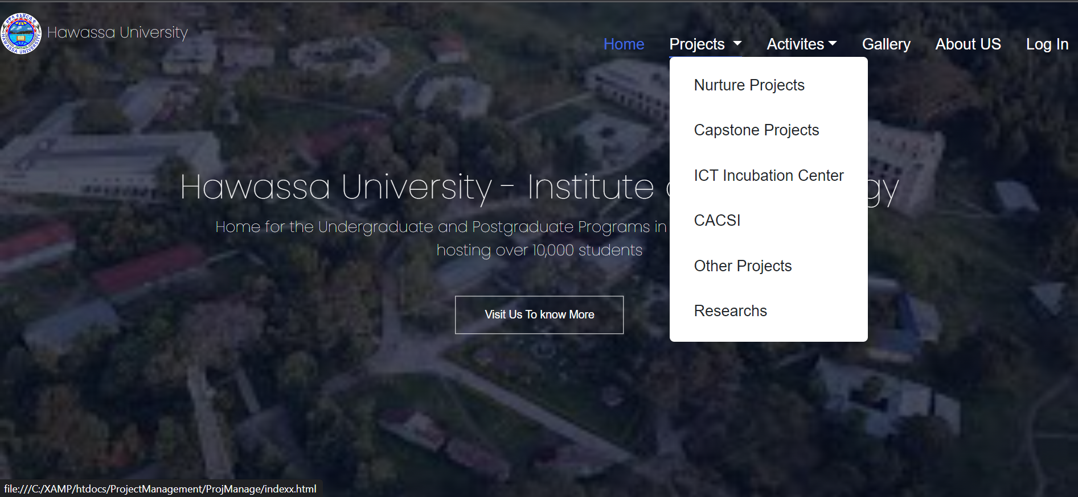

Fig 6.1 Home Page

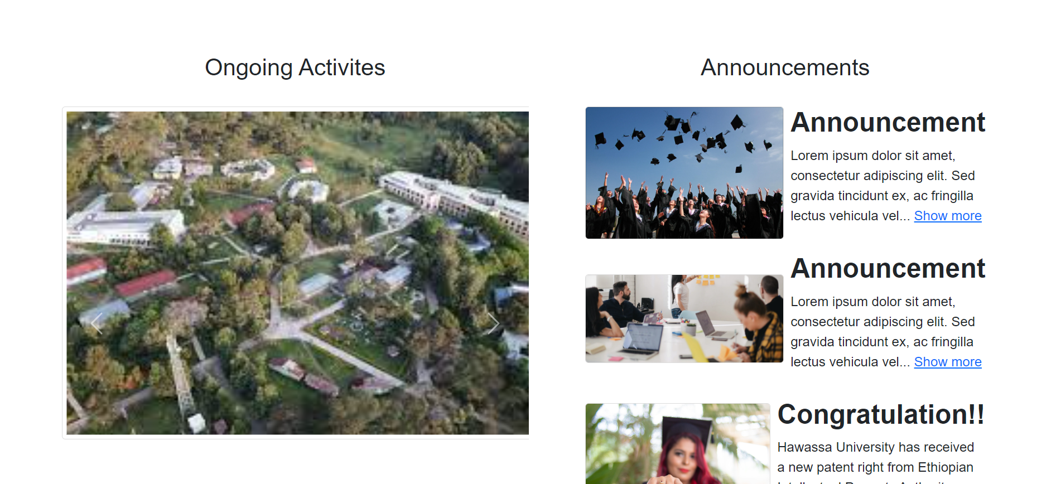

Fig 6.2 Home Page

**Projects Page**

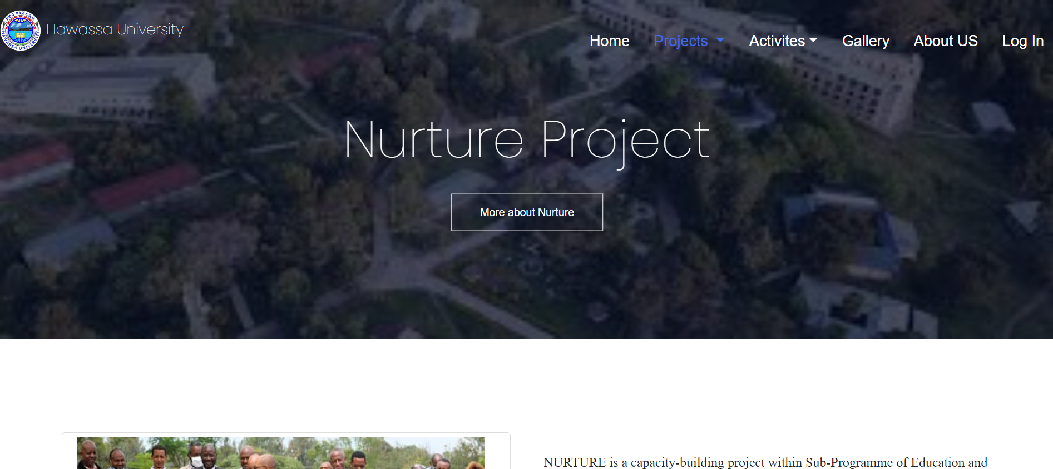

Fig 6.3 Projects Page

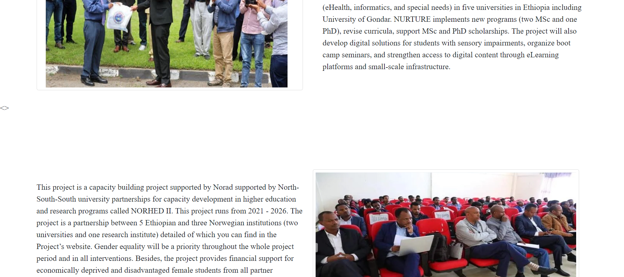

Fig 6.4 Projects Page

**About Us Page**

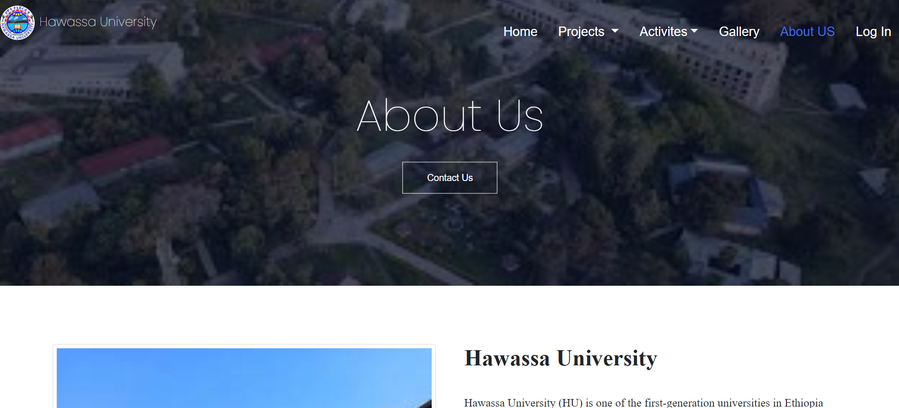

Fig 6.5 About Us Page

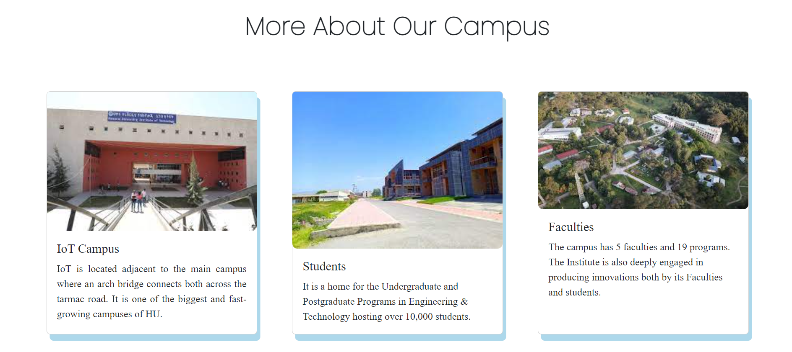

Fig 6.6 About Us Page

**Admin Dashboard**

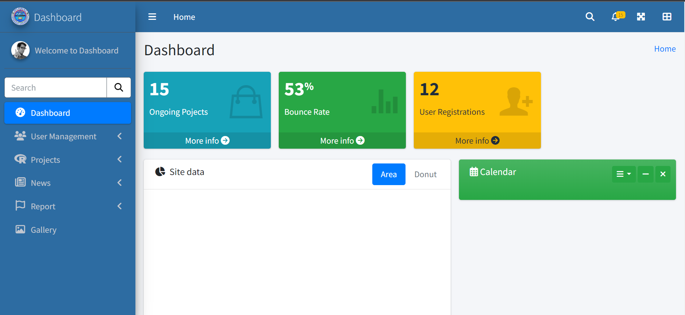

Fig 6.7 Admin Dashboard

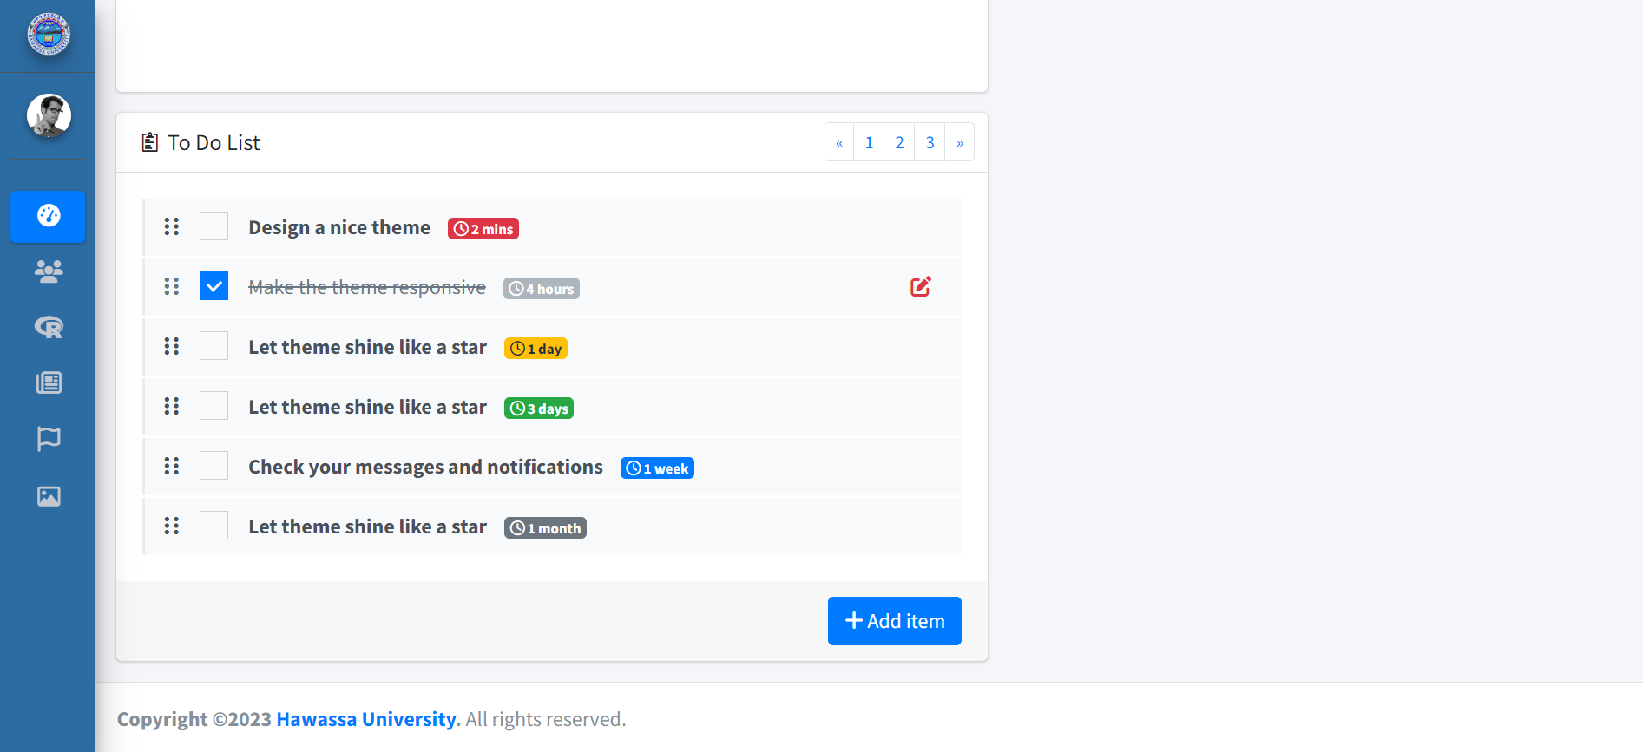

Fig 6.8 Admin Dashboard

**Users Page**

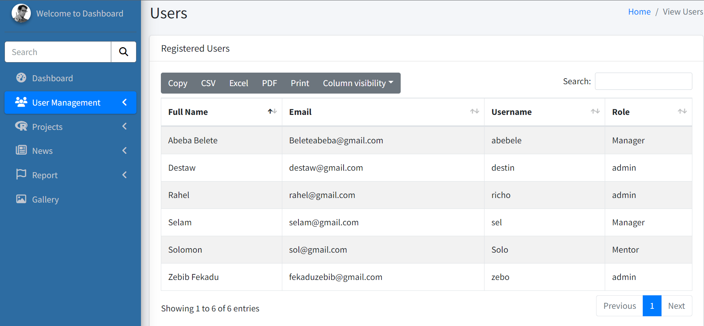

Fig 6.9Users Page

**Projects Page | Admin**

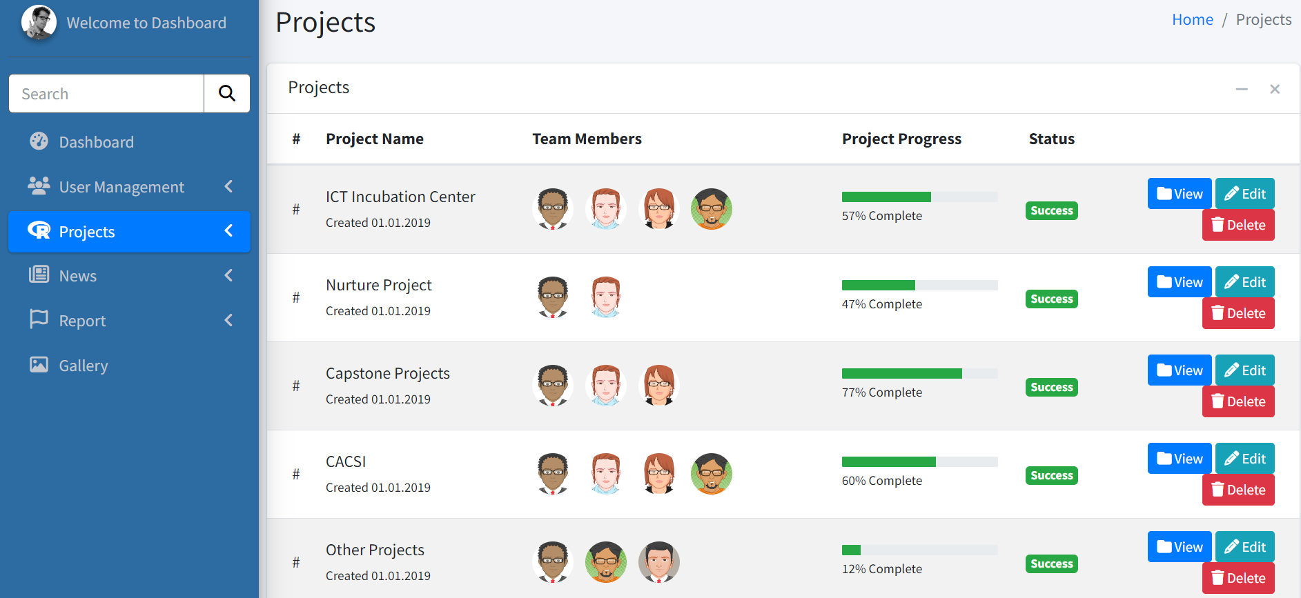

Fig 6.9 Projects Page | Admin

* 1. **Database Design**

These are the set of entities created for the database. The entities and their description are listed as follows:

**Account**

* **Account ID:** primary key
* **Username**: A unique identifier for the admin account.
* **Full Name**: The name of the admin.
* **Password**: A secure string of characters used to authenticate the admin account.
* **Email**: The email address associated with the admin account.
* **Role**: The role of the user, (admin, financial officer, project manager…).
* **Last login**: The date and time of the admin’s last login.
* **Created at**: The date and time when the admin account was created.

**Announcement**

* **Announcement ID**: unique identifier for the announcement, primary key.
* **Title**: A short and descriptive title for the announcement.
* **Description**: A detailed description of the announcement.
* **Date**: The date when the announcement was created or updated.
* **Author**: The name of the person who created the announcement.
* **Category**: The category or type of the announcement (e.g., news, event, update).

**Activities**

* **Activity ID:**
* **Activity type:**
* **Location:**
* **P_ID:** foreign key, under what project is this activity built
* **Participant ID**: who participated in the activities

**Project**

* **Name**: A unique identifier for the project.
* **Description**: A detailed description of the project.
* **Start date**: The date when the project starts.
* **End date**: The date when the project ends.
* **Status**: The status of the project (e.g., active, completed).
* **Assigned to**: The person or team responsible for completing the project.
* **Created at**: The date and time when the project was created.

**Plan**

* **P_ID**: unique identification for the plan, primary key.
* **Title**: A short and descriptive title for the plan.
* **Description**: A detailed description of the plan.
* **Objective**: The objective or goal of the plan.
* **Start date**: The date when the plan starts.
* **End date**: The date when the plan ends.
* **Status**: The status of the plan (e.g., active, completed).
* **Assigned to**: The person or team responsible for executing the plan.
* **Created at**: The date and time when the plan was created.

**Stakeholders**

* **Stakeholder’s Name**: Name of the organization, primary key.
* **Date of association:** when they started being associated.
* **P_ID:** foreign key, project they participated in

**Participants**

* **Participant name:** Full name of the participants
* **Participant id:** Unique identification of the participants
* **Occupation:** their job
* **P_ID:** foreign key, the project they participated in
* **Role:** the role they have in the project.
* **Testimonial:** Testimonial they gave about the projects they participated in.

**Gallery**

* **Gallery ID:** primary key
* **Image URL:**
* **P_ID:** foreign key, which project’s
* **Caption:**

**Feedback**

* **Feedback id:** primary key
* **Feedback given**:
* **Name**:
* **Date**: The date when the feedback was received.

**Report**

* **Report id:** primary key,
* **P_ID:** Under what project is the report being submitted
* **Description:**
* **Date:** when was the report written
* **Account Id:** foreign key.
* **Author:** Who wrote the report

**Entity Relation Diagram**

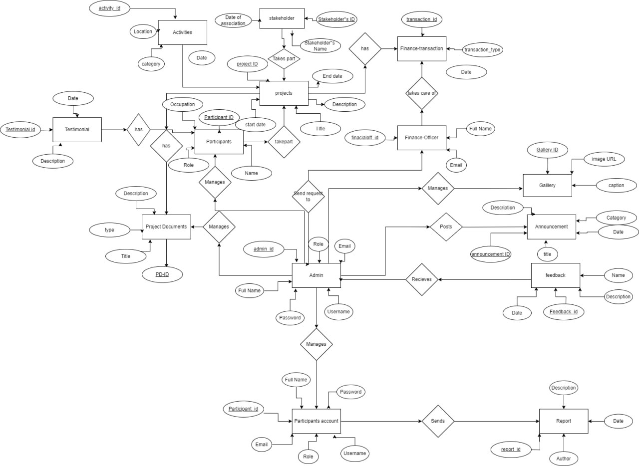

Fig 6.10 ER Diagram

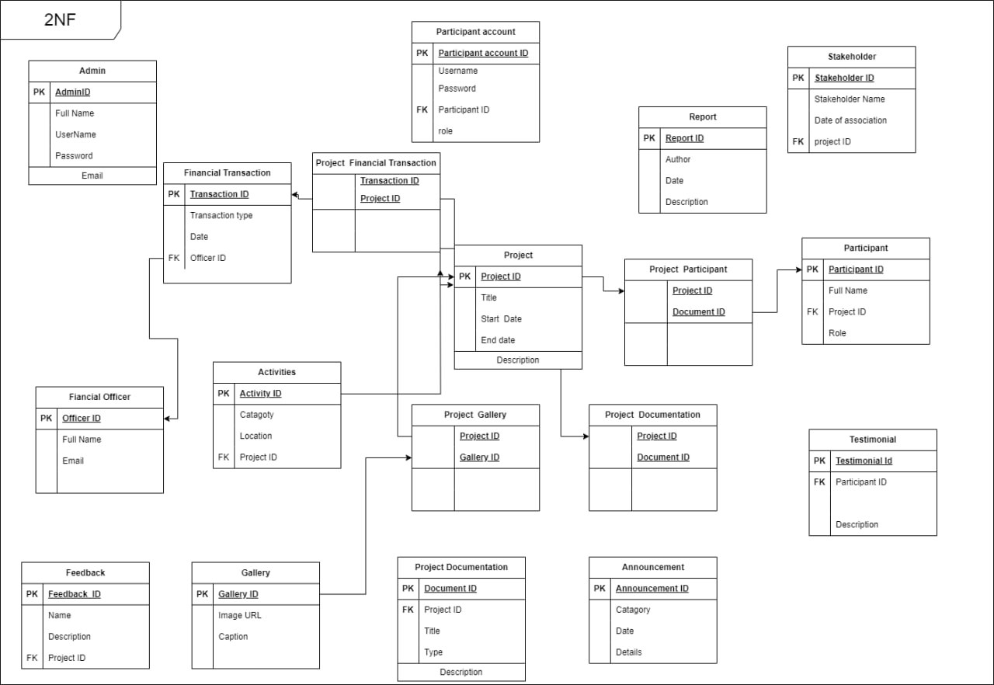

Fig 6.11 2nd Normal Form

1. **Conclusion & Recommendation**
   1. **Conclusion**

HU – CACSI is working all the time to sustain & satisfy the needs of the University & the students. According to our own experience of the working environment, the CACSI is a very inspiring section that is thriving to make change & increase the interest of the students in innovation & technology.

* It is known that the main goal of the apprenticeship program is to gain both theoretical & practical knowledge, including the way to integrate & use it efficiently. As such, Informatics faculty students are more effective in achieving the intended learning competency as they have developed their practical knowledge in addition to what they have learnt theoretically according to the curriculum.
* In addition to the technical & theoretical knowledge that we’ve gathered this program also helped us gain an insight into what the real world looks like. We have learned team work, work ethics & communication skills throughout out this duration.
* In conclusion, this apprenticeship was very important experience that we gained and we expect that we will use this useful guidance in the future when we enter the work-field.
  1. **Recommendation**

During our internship experience period we have seen some positive & negative sides about both the internship hosting company & the University. In this part of the report we will try to suggest some ideas for our internship hosting company & our university.

1. **For our Hosting company**

This apprenticeship program hold benefits to the field supervisor and hosting company by providing motivated workers at no or relatively small cost to an organization and furnishing the opportunity to train possible future employees for the organization. Participating in this program allows the field supervisor & organization to maintain a working relationship with the university in which we are attending our courses. In several cases, special projects, like the one we were doing, need more time, expertise and attention. Therefore we suggest that, when giving this kind of projects, the students must be provided with some trainings, affordable time schedule & continuous help form the supervisor & the hosting company.

1. **For our University**

This apprenticeship program is dedicated so that students can learn & acquire some practical knowledge in addition to the theoretical knowledge & other soft skills. We attended this program for six weeks, 1 day per week. This is a total of 6 days spent at the company. The knowledge & skills to be acquired within this short period of time is actually questionable. Since this program is supposed to help students face the real world & work environment, we suggest that a wider slot of time is allocated for this program.

Aside from that, this program is very efficient in preparing students for the next phase of their life which is the work life. We recommend that the university keeps on giving internship chances, with a longer duration for students.

1. **References**

<https://www.scribd.com/document/564559061/report-hawassa-university>

<https://nurture.usn.no/>

<https://www.norad.no/en/front/funding/norhed/>

<https://www.hu.edu.et/index.php/hu/overview/background>

<https://developer.mozilla.org/en-US/docs/Web/HTML>

<https://www.w3schools.com/html/default.asp>

<https://developer.mozilla.org/en-US/docs/Web/CSS>

<https://www.w3schools.com/css/default.asp>

<https://developer.mozilla.org/en-US/docs/Web/JavaScript>

<https://www.w3schools.com/js/default.asp>

<https://getbootstrap.com/docs/5.3/getting-started/introduction/>

<https://www.w3schools.com/bootstrap5/index.php>

Industrial_Attachment_Report_Computer_SC.docx

Internship-report-sample-6.pdf

Computer_Science_Industrial_Attachment_R.docx